‘Let’s write things in the snow’: How to make Christmas Bunting

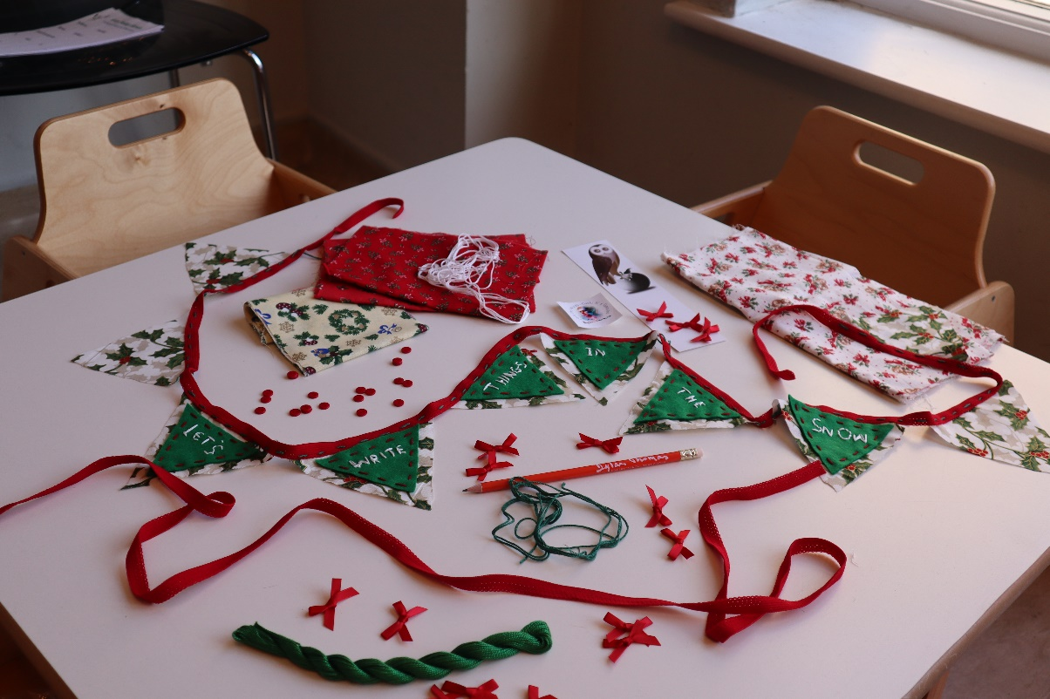

You will need:
- Scraps of fabric
- Scrap paper for a template
- Scissors
- Needle and thread
- Ribbon

‘Our snow was not only shaken from whitewash buckets down the sky, it came shawling out of the ground and swam and drifted out of the arms and hands and bodies of the trees…’

As you can tell from the quote above, Dylan loved a bit of snow. Whilst we can’t guarantee any of the white fluffy stuff for December, we can use his words to inspire us in our festive creations. In this activity guide you will learn how to make one of the easiest (but most impressive) decorations there is: bunting. You don’t have to have much technical skill to make bunting, because it’s meant to look charmingly simple. However, if you are a seasoned stitcher, you can choose to make it as intricate as you like! We also love bunting for environmental reasons: it uses up scraps of fabric that might otherwise end up in landfill, and the bunting itself can be re-used year after year.

For our Dylan Thomas themed bunting, we have decided to embroider the triangles with a quote from his wonderful seasonal tale, ‘A Child’s Christmas in Wales.’ You might like to read this story to give you some inspiration for your own design. Here are some of our favourite (short) quotes, to get you started.

‘carol-singing sea’ ‘a ringing of bells’
‘it was snowing’ ‘we went singing carols’
‘eternal snows’ ‘snow-felted dreams’
‘it snowed and it snowed’ ‘tinselled windows’
‘snow grew over night’

How to make your bunting:

- Source some fabric. This can be as simple as cutting up a holey old t-shirt, or some trousers that have worn through the knees. Select anything that is no longer fit for purpose. If you can’t find any fabric then you can alter this guide for paper and card and exchange all the sewing instructions for glue or staples. To make this bunting festive, you might want to use fabric or paper that is red or green. Or perhaps white and blue, for the snow!

- Bunting is usually made from a series of triangles. These triangles can be as precise or inexact as you like. If you don’t feel confident, it might be best to draw a triangle on a piece of paper, cut it out, and use that as a guide. We suggest that you will need at least 12 triangles to make the bunting long enough – but more is better. As with anything involving scissors, please take care!

- We cut out two sets of triangles in two different fabrics. This is an easy way to make the bunting stand out. By choosing a patterned fabric for the large triangle and a plain fabric for the small one, you ensure your embroidered words will stand out. You will need to cut the interior set of triangles slightly smaller so that when they are stitched on there is a border created by the base fabric [see image]. If you intend to embroider quotes, do not stitch these triangles together just yet. If you don’t want to do quotes, skip to step 5.

- Taking the smaller triangles, count out how many you will need for your quote. If you are doing a longer quote you might choose one triangle per word. For a shorter quote you might use a triangle per letter. So, to embroider ‘eternal snows’ you will either need to separate out two small triangles or twelve small triangles. Stitching on the words is the fun part and it’s ok if the letters don’t always come out the way you expected. If you are using paper and card, you can simply write the quote on, and if you don’t feel confident with a needle and thread you could also use a strong marker-pen on the fabric.

- Now you need to stitch the small triangles onto the big triangles, centralising them so there is a border. You can stitch these however you like, because this is another part where inexactness just adds to the charm.

- Once you have all your triangles prepared – including blank ones for the gaps between words if applicable – it’s time to fix them to some string or ribbon. To avoid missing out words, letters, or spaces, we advise laying all the triangles out on a table or the floor in the exact order they should appear on the bunting. Then lay the ribbon or string along the length of triangles and add in about 20cm of length to both ends (so you can tie it up). You don’t need to cut the ribbon/string yet, you can just start sewing at one end and wait until you fix the last triangle. Begin about 20cm in, and pick up the first triangle in your pre-arranged row. Continue until all are fixed on, and then snip off the excess whilst leaving 20cm as a tie.

- You are finished! Now you just need to hang it where everyone can appreciate it.

