Choose your words!

Dylan Thomas often created his own wordlists to help him write his poems, and ensure that he chose the best possible words for each line. Sometimes he wrote the lists on his manuscript, as you can see on this worksheet for ‘Poem on his birthday’ which is on display in our ‘Love the Words’ Exhibition:

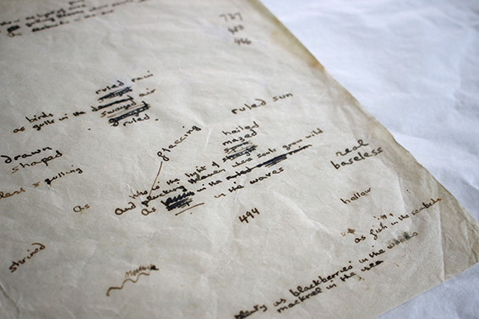

To get you started on writing a poem of your own, choose a word from each of the columns. What unusual combination will you come up with? Will you have an enormous dancing sloth, or a tiny singing tiger? Use this as the starting point for a poem!

tiny jumping dragon
surprised sleeping fox
enormous snarling slug
shy singing heron
joyful flying kitten
impatient dancing tiger
hungry laughing dolphin
playful swimming elephant
forgetful roaring sloth

This is our poem: The happy dancing tiger
Surprised the sleeping slug
‘I’m hungry!’ roared the dragon
As the enormous elephant swam away.

Don’t forget to share your poems with us @DTCSwansea on Twitter, www.facebook.com/DylanThomasCentre or on email to dylanthomas.lit@swansea.gov.uk

